1. 
2. We just talked about sharding and replication.
3. Sharding enables Elasticsearch to **scale** the number of documents an index can store, by splitting it into smaller pieces. But if we don’t add more nodes to our cluster, the no of shards is not going to help us because eventually we will run out of disk space.
4. Likewise replication only kicks in for clusters consisting of more than one node.  
   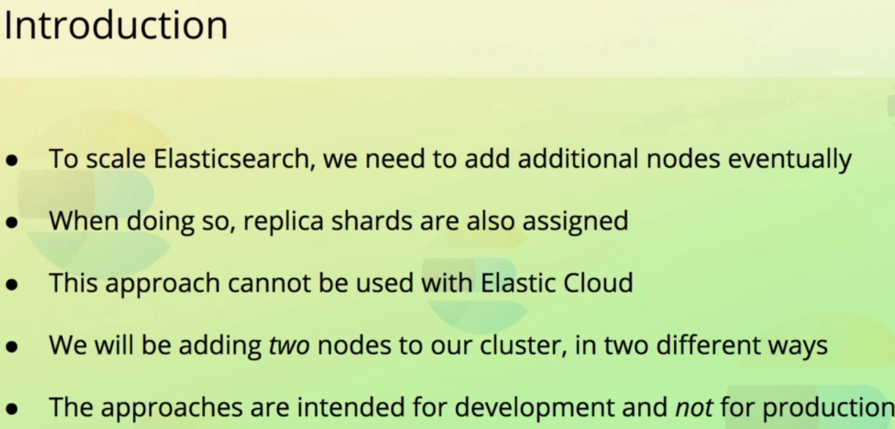
5. Let’s add node and see how cluster behaves.
6. 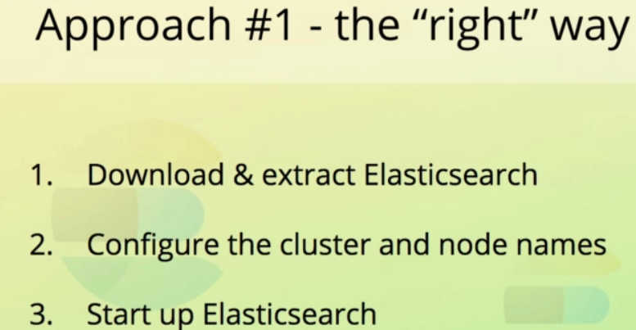
7. 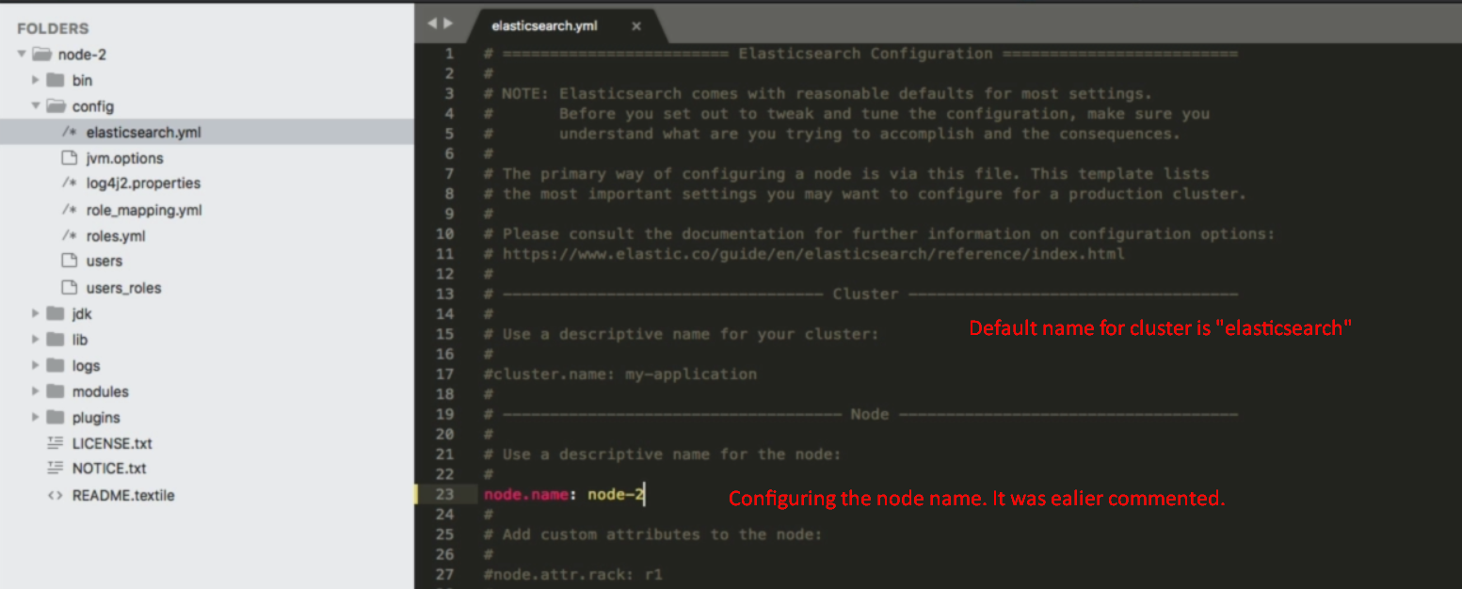
8. 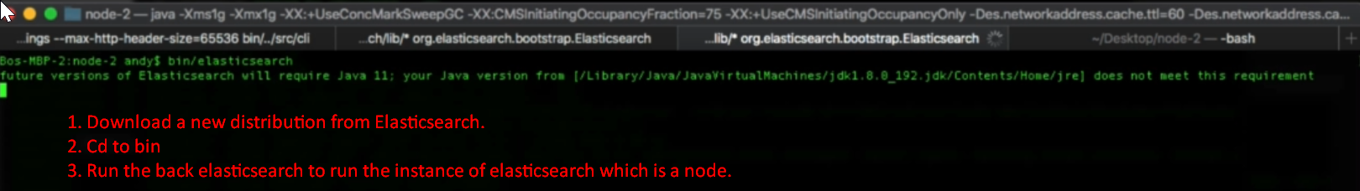
9. 
10. 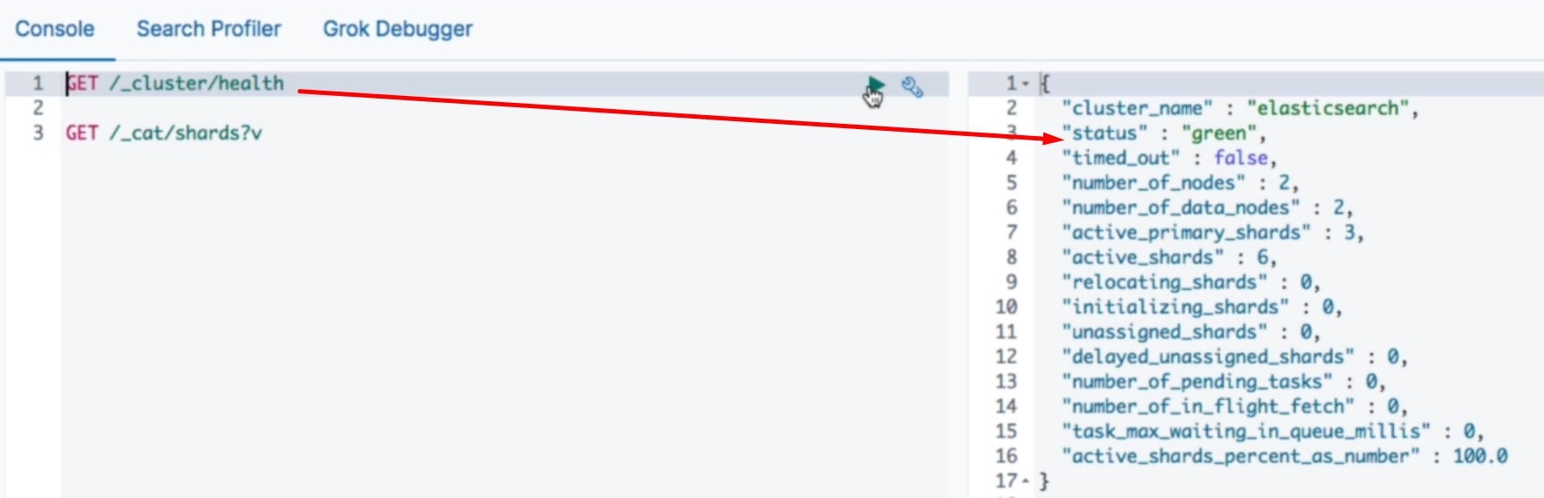
11. 
12. 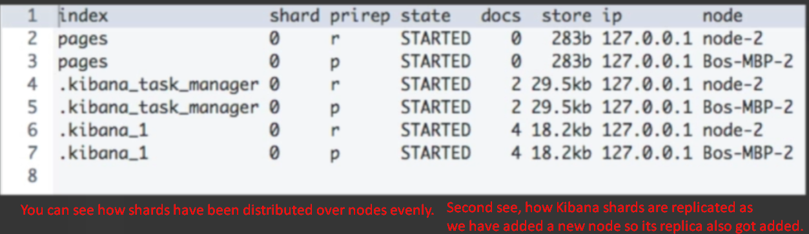

Let’s add another node to the cluster just in another way.

1. 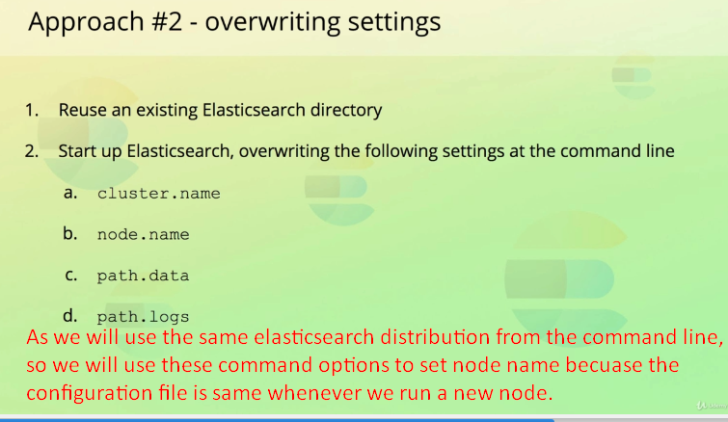
2. 